Gathering
Prelude
Welcome & Announcements
*Call to Worship Psalm 124:8
The Lord be with you.
And also with you.
Our help is in the name of the Lord,
who made heaven and earth.
*Opening Prayer
*Hymn # 462 Christ, Whose Glory Fills the Skies
*Confession of Sin 1 John 1:8,9
Merciful God, we confess that we have sinned against you in thought, word, and deed, by what we have done, and by what we have left undone. We have not loved you with our whole heart and mind and strength. We have not loved our neighbors as ourselves. In your mercy forgive what we have been, help us amend what we are, and direct what we shall be, so that we may delight in your will and walk in your ways, to the glory of your holy name.
*Declaration of Pardon
*The Peace John 20:19
The peace of our Lord Jesus Christ be always with you.
And also with you.
*Hymn # 579 Gloria Patri
The Word
Prayer for Illumination Rev. 2:7
First Reading Exodus 20:1-4, 7-9, 12-20
The Word of the Lord.
Thanks be to God.
Psalm Psalm 19
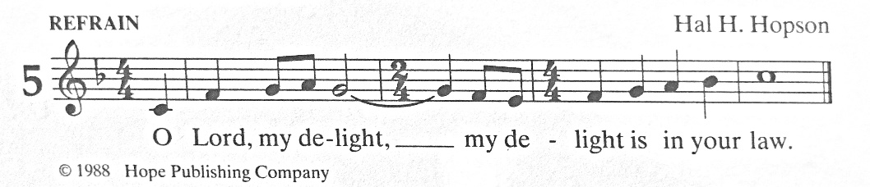

Second Reading Philippians 3:4b-14
The Word of the Lord.
Thanks be to God.
*Hymn # 331 Thanks to God Whose Word Was Written
*Gospel Reading Matthew 21:33-46
The Gospel of the Lord.
Praise to you, O Christ.
Sermon
*Hymn # 417 Christ Is Made the Sure Foundation
*Affirmation of Faith Apostles’ Creed
I believe in God, the Father almighty, creator of heaven and earth. I believe in Jesus Christ, God’s only Son, our Lord. who was conceived by the Holy Spirit, born of the Virgin Mary, suffered under Pontius Pilate, was crucified, died, and was buried; he descended to the dead, on the third day he rose again; he ascended into heaven, he is seated at the right hand of the Father, he will come again to judge the living and the dead. I believe in the Holy Spirit, the holy catholic church, the communion of saints, the forgiveness of sins, the resurrection of the body, and the life everlasting. Amen.
Sharing of Joys & Concerns
*Prayers of the People
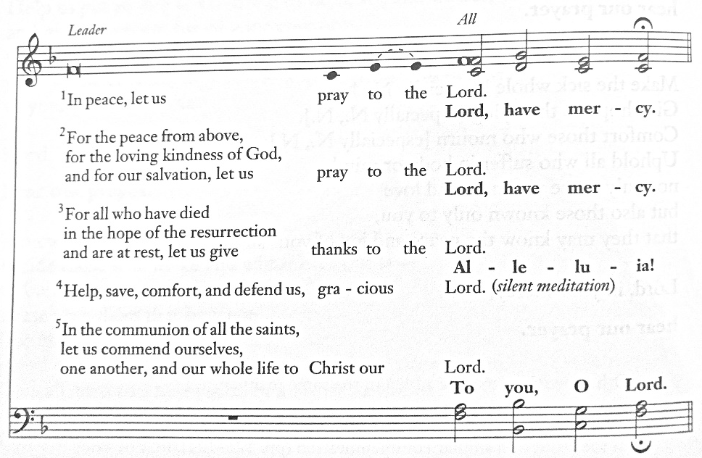
Offering Heb. 13:16
*Hymn # 592 Doxology
*Prayer of Thanksgiving
Let us give thanks to the Lord our God.
It is right to give our thanks and praise.
*Lord’s Prayer
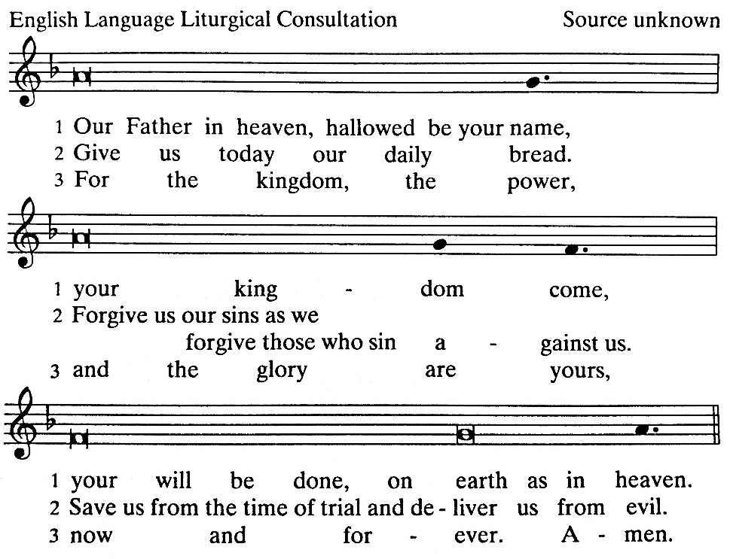
Sending
*Hymn # 539 Savior, Again to Thy Dear Name We Raise
*Charge & Blessing Phil. 4:7
Amen. Alleluia!
Postlude

The presider’s text is printed in plain type.
The congregation’s responses are printed in boldface.
Liturgical directions are printed in italics.
An asterisk (*) indicates to stand or remain standing, if able.

Permissions
Scripture readings are taken from the New Revised Standard Version (NRSV).
© 1989 National Council of Churches.
Liturgy is taken from The Book of Common Worship.
© 1993 Westminster John Knox Press
Music is reprinted with permission from The Book of Common Worship and
The Psalter: Psalms and Canticles for Singing

