St. Luke’s Episcopal Church
Kalamazoo, MI

The Burial of the Dead
Patrick Merrill Jones
March 11, 1931 – November 24, 2024
Officiant: The Rev. J. Barrett Lee, Obl OSB
Organist: Dr. Karl Schrock
Prelude “Brother James’ Aire” Searle Wright (1918-2004)
Please rise, in body or spirit, as able.
Hymn “When Peace Like a River” [LEVAS-II #188]
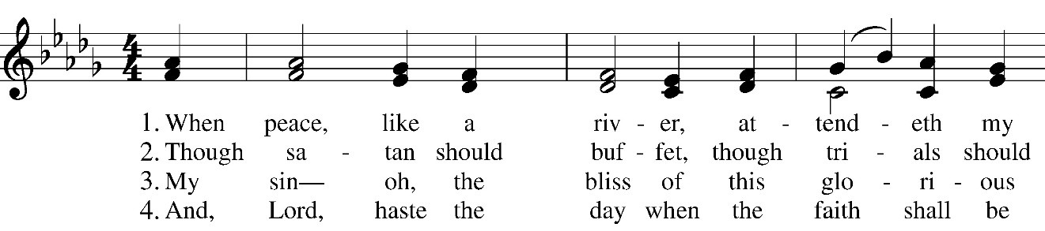
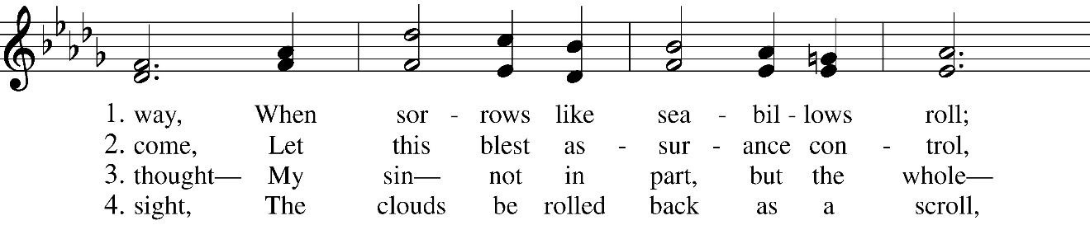
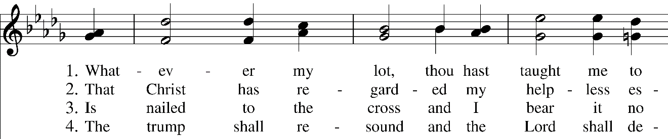
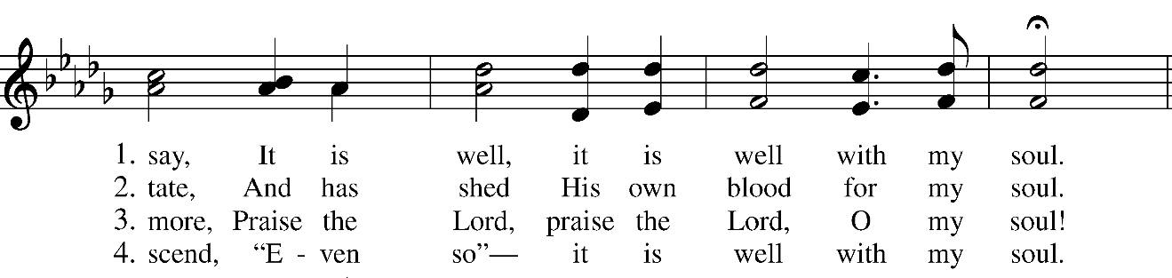

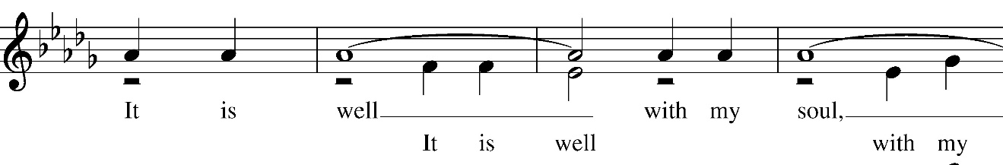
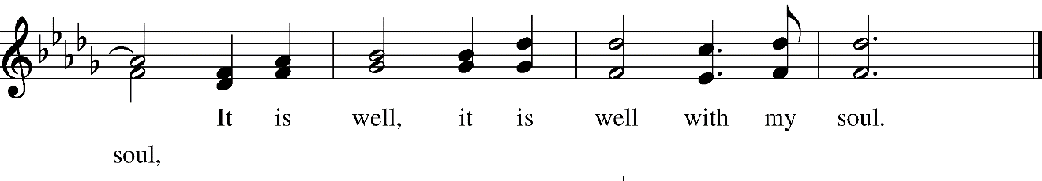

When all are in place, the Officiant addresses the congregation, acknowledging briefly the purpose of the gathering, and bidding their prayers for the deceased and the bereaved.
Officiant | The Lord be with you
People | And also with you.
Officiant | Let us pray.
Silence may be kept; after which the Officiant says the following Collect
O God of grace and glory, we remember before you this day our brother Patrick. We thank you for giving him to us, his family and friends, to know and to love as a companion on our earthly pilgrimage. In your boundless compassion, console us who mourn. Give us faith to see in death the gate of eternal life, so that in quiet confidence we may continue our course on earth, until, by your call, we are reunited with those who have gone before; through Jesus Christ our Lord. Amen.
The Officiant adds the following prayer
Most merciful God, whose wisdom is beyond our understanding: Deal graciously with Patrick’s friends and family. in their grief. Surround them with your love, that they may not be overwhelmed by their loss, but have confidence in your goodness, and strength to meet the days to come; through Jesus Christ our Lord. Amen.
The people sit.

The Liturgy of the Word
First Reading: 2 Corinthians 4:16-5:9
A reading from the second letter of Paul to the Corinthians.
So we do not lose heart. Even though our outer nature is wasting away, our inner nature is being renewed day by day. For our slight, momentary affliction is producing for us an eternal weight of glory beyond all measure, because we look not at what can be seen but at what cannot be seen, for what can be seen is temporary, but what cannot be seen is eternal.
For we know that, if the earthly tent we live in is destroyed, we have a building from God, a house not made with hands, eternal in the heavens. For in this tent we groan, longing to be further clothed with our heavenly dwelling, for surely when we have been clothed in it we will not be found naked. For while we are in this tent, we groan under our burden because we wish not to be unclothed but to be further clothed, so that what is mortal may be swallowed up by life. The one who has prepared us for this very thing is God, who has given us the Spirit as a down payment.
So we are always confident, even though we know that while we are at home in the body we are away from the Lord— for we walk by faith, not by sight. Yes, we do have confidence, and we would rather be away from the body and at home with the Lord. So whether we are at home or away, we make it our aim to be pleasing to him.
The Word of the Lord.
Thanks be to God.
Psalm 23 Dominus regit me
The LORD is my shepherd; *
I shall not be in want.
He makes me lie down in green pastures *
and leads me beside still waters.
He revives my soul *
and guides me along right pathways for his Name's sake.
Though I walk through the valley of the shadow of death,
I shall fear no evil; *
for you are with me;
your rod and your staff, they comfort me.
You spread a table before me in the presence of those
who trouble me; *
you have anointed my head with oil,
and my cup is running over.
Surely your goodness and mercy shall follow me all the days
of my life, *
and I will dwell in the house of the LORD for ever.

The Gospel: John 6:37-40
Then, all standing, the Deacon or Minister appointed reads the Gospel, first saying
The Holy Gospel of our Lord Jesus Christ
according to John.
People | Glory to you, Lord Christ.
Jesus said, “Everything that the Father gives me will come to me, and anyone who comes to me I will never drive away, for I have come down from heaven not to do my own will but the will of him who sent me. And this is the will of him who sent me, that I should lose nothing of all that he has given me but raise it up on the last day. This is indeed the will of my Father, that all who see the Son and believe in him may have eternal life, and I will raise them up on the last day.”
At the end of the Gospel, the Reader says
 | The Gospel of the Lord.
People | Praise to you, Lord Christ.
The Homily
The Lord’s Prayer
And now, as our Savior Christ has taught us, we are bold to say,
Our Father, who art in heaven,
hallowed be thy Name,
thy kingdom come,
thy will be done,
on earth as it is in heaven.
Give us this day our daily bread.
And forgive us our trespasses,
as we forgive those
who trespass against us.
And lead us not into temptation,
but deliver us from evil.
For thine is the kingdom,
and the power, and the glory,
for ever and ever. Amen.

The Prayers of the People
Dear Friends: It was our Lord Jesus himself who said, "Come to me, all you who labor and are burdened, and I will give you rest." Let us pray, then, for our brother Patrick, that he may rest from his labors, and enter into the light of God's eternal sabbath rest.
Receive, O Lord, your servant, for he returns to you.
Into your hands, O Lord,
we commend our brother Patrick.
Wash him in the holy font of everlasting life, and clothe him in his heavenly wedding garment.
Into your hands, O Lord,
we commend our brother Patrick.
May he hear your words of invitation, "Come, you blessed of my Father."
Into your hands, O Lord,
we commend our brother Patrick.
May he gaze upon you, Lord, face to face, and taste the blessedness of perfect rest.
Into your hands, O Lord,
we commend our brother Patrick.
May angels surround him, and saints welcome him in peace.
Into your hands, O Lord,
we commend our brother Patrick.
The Officiant concludes
Almighty God, our Father in heaven, before whom live all who die in the Lord: Receive our brother Patrick into the courts of your heavenly dwelling place. Let his heart and soul now ring out in joy to you, O Lord, the living God, and the God of those who live. This we ask through Christ our Lord. Amen.
The Commendation
The Officiant and other ministers take their places at the body.
Hymn “Amazing Grace! How Sweet the Sound” [h82 #671]
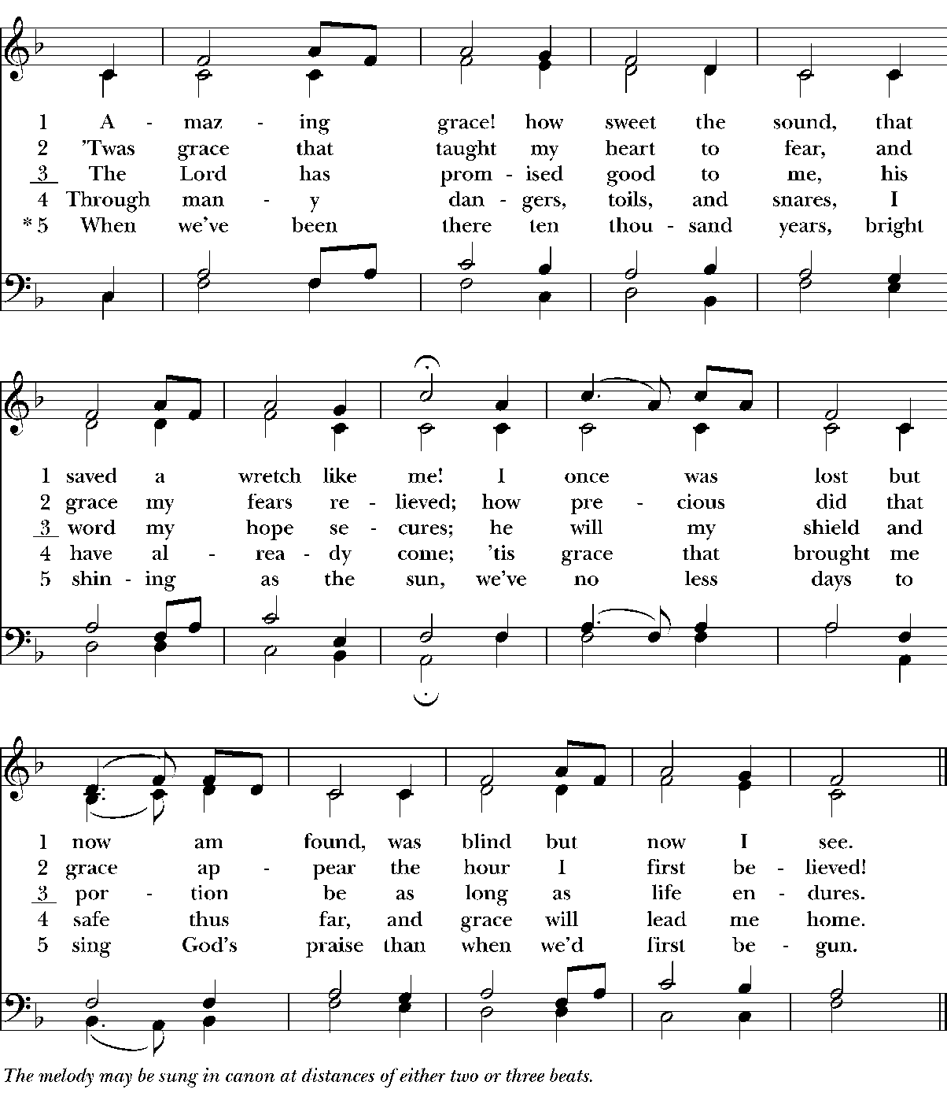
The Officiant, facing the body, says
Into your hands, O merciful Savior, we commend your servant Patrick. Acknowledge, we humbly beseech you, a sheep of your own fold, a lamb of your own flock, a sinner of your own redeeming. Receive him into the arms of your mercy, into the blessed rest of everlasting peace, and into the glorious company of the saints in light. Amen.
The Dismissal
Let us go forth in the name of Christ.
Thanks be to God.
As the body is borne from the church this anthem is sung.
Anthem
Into paradise may the angels lead you.
At your coming may the martyrs receive you,
and bring you into the holy city Jerusalem.
May the choirs of angels welcome you,
and with Lazarus who once was poor
may you have peace everlasting.
Postlude “O God, Our Help in Ages Past” Heinrich Fleischer (1912-2006)

Music (In order of appearance)

Brother Jame’s Air. Searle Wright (1918-2004). ©1958 Oxford University Press; podcast permission grated under
OneLicense.net # A-723320.

“When peace, like a river.” Words: Horatio Spafford (1828-1888). Music: Philip P. Bliss (1838-1876). ©2022 Beckenhorst
Press, Inc. Reprint permission granted under OneLicense.net # A-723320.

“Amazing grace! How sweet the sound.” Words: John Newton (1725-1807), alt.; st. 5, John Rees. ©2014 Alfred Publishing;
reprint permission granted under OneLicense.net # A-723320. Music: New Britain, from Virginia Harmony, 1831;
adapt. att. Edwin Othello Excell (1851-1921). Harm. Austin Cole Lovelace (1919-2010). © 1974 by Abingdon
Press; reprint under OneLicense.net # A-723320.

O God, Our Help in Ages Past. Heinrich Fleischer (1912-2006), ©1952 Concordia Publishing House. Reprint permission
granted under OneLicense.net # A-723320.

